Jamie Davies Aug 2014
Imaginal discs, growth and gradients.

1) What are imaginal discs?
Holometabolous insects have two very different body forms during their lives. First, hatching from the egg, is a larval form (for example, the maggot of a fly). This may go through a series of moultings as it grows to be a bigger and bigger larva. At the end of larval stage, the organism enters the pupal stage, and emerged with the fully adult form.

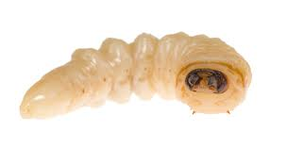  Housefly: larval form | 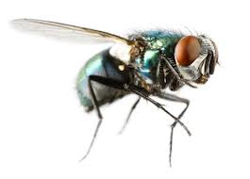  Housefly: adult form

In order to be able to make an adult body, the larval form carries inside itself a series of disc-like epithelial pouches. During pupal life, these discs evaginate to become extremely elongated cones or sheets to form external features such as legs and wings, as below:

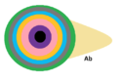  The concentric zones of this disc have been colour-coded so that you can see how the centre of the disc becomes the foot of the leg, and so on, in the adult image to the right. | 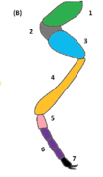

2) Positional information in imaginal discs
You have already met the idea of positional information in a tissue being determined by a morphogen gradient. You have also met a convenient 1970s model for this type of system: Lewis Wolpert's 'French flag', in which a morphogen is made at one side of the flag, diffuses away and is destroyed at a fixed probability-per-unit-time. In the model, cells use the morphogen concentration they experience to decide whether to be in the differentiated state as 'blue', 'white', 'red'. The beauty (utility, anyway) of this system is that cells do not actually have to have a way of measuring their physical position directly (eg by reaching out across the tissue), but can just use local conditions to determine their behaviour.

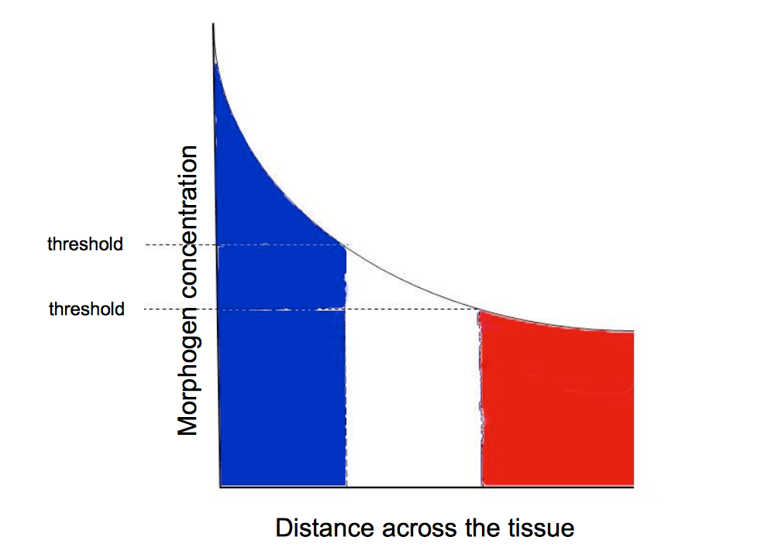

Imaginal discs seem to use such a system. In the wing disc of the fruitfly, Drosophila melanogaster, for example, the morphogen is a protein called Decapentaplegic ('Dpp'). The system is a little more complicated than the French flag, in that the source of Dpp is a stripe that runs along the midline so there is effectively a 'French flag' forward and reverse:

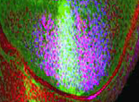  This is a real photo of the wing disc of a fly in which Dpp glows green, and the expression of a response gene ('Spalt', though you do not need to know this) is blue. This photo is from Teleman AA & Cohen SM (2000) Cell 103:971-890. | 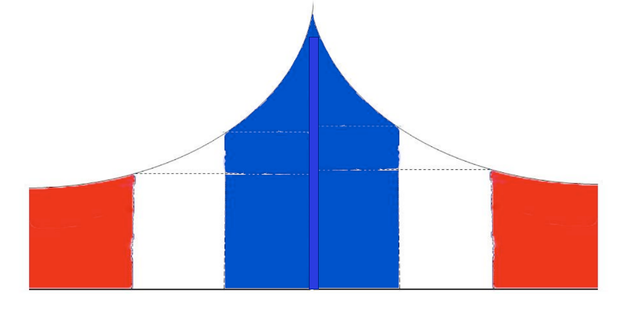  This cartoon just shows the flag facing both ways, as it would from a central source.

The Dpp gradient is important to development of the wing: without it the different structures at the leading, central and trailing edges of the wing do not form properly and the wing would not work as a device for flying. (Dpp is not the only positional information system in the wing discs, but for simplicity this practical focuses on just this one: I am telling you this only to stopj you being puzzled if you meet other systems later in your studies).

3) The problems of growth.
Imaginal discs start life small and grow until they are large enough to make the structures of the adult. This growth involves substantial cell proliferation. This creates a potential problem for a morphogen gradient-based system. If the morphogen gradient is right for a small tissue, then it will be inadequate for a larger one:

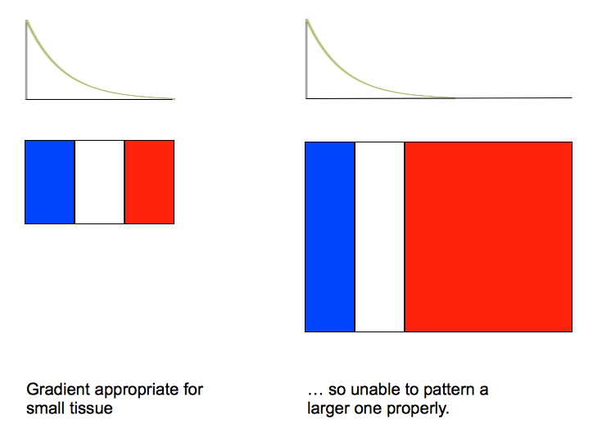 | In this example, the gradient parameters were correct for the small tissue. When the tissue grew, it extended beyond the range of the gradient, in this case meaning that the most of the tissue differentiates to be 'red'.

One possible way round this (in principle) would be for the tissue to use a gradient that is correct for its adult size, and have cells only making decisions based on positional information once adult size had been reached.

There is a problem with this idea, though. Flies raised in crowded conditions in which food is scarce are much smaller than wild-type. Flies with mutations in the insulin-like growth factor signalling system are also small. In both cases, though, they are 'small but perfectly formed', with wings patterned normally. This is a strong argument that morphogen gradients cannot be set up in advance at 'adult size' and tissues just grow into that size before the gradient is actually used to control development.

Somehow, therefore, morphogen gradients and actual tissues must expand in step with one another, so that they always scale.

4) A word about 'scaling'
Later in this practical, you will need to know what 'scaling' means: quite simply, if things grow in a way that 'scales', you would not know without any indication of absolute size whether you are looking at a small or big version.

These two objects scale (one image is just an enlargement of the other):

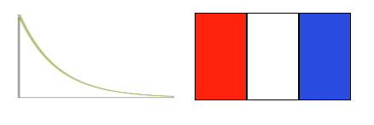

These do not (in this case because, although the overall shape is the same at a different scale, the individual bricks have not changed in size although there are more of them).

 | 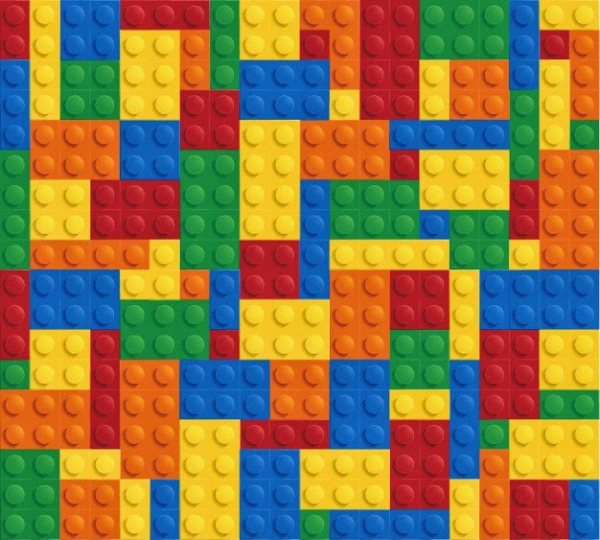

This pair also do not scale, because the graph has stretched along only the x axis (contrast this with the example of scaling at the top of this section on scaling):
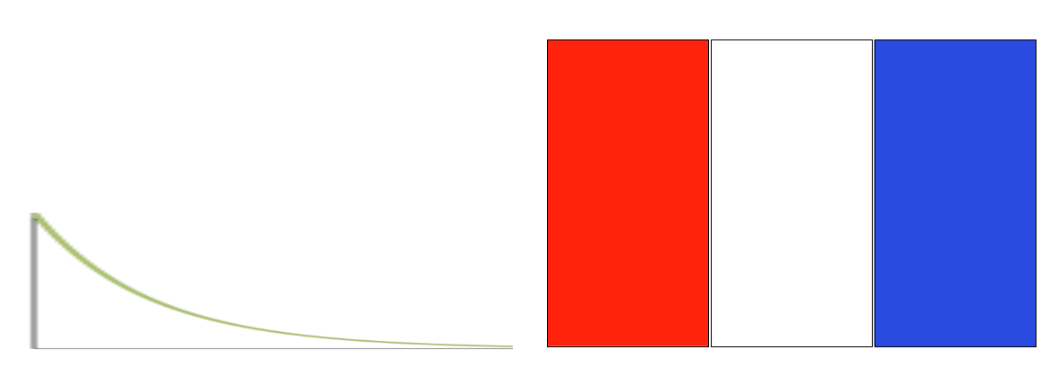

OK – you can now go to the questions. I suggest you leave this pdf open somewhere on your screen so that you can refer to it again (this is not meant to be a memory test!).

