Renal Module Lectures 1-6:

The function and development of the urinary system.

Prof. Jamie Davies

Slides, podcasts, practice questions etc. can be found at
http://golgi.ana.ed.ac.uk/coursenotes/mbchbyr2/renal.html

Purpose of these notes:
These notes are provided to give you a ‘bottom line’ summary of the most important points in my lectures. They do not cover everything I will tell you, but just the absolute minimum you really need to understand. They are meant to be used as a revision aid rather than as a means of primary learning. You will find that the recommended book – Field, Pollock, Harris The Renal System (Churchill Livingstone) – will also be a valuable aid to revision, particularly because it provides the same information about renal function but in a different order so will give you new ways in to the information. O’Callaghan’s The Renal Systsem at a Glance (Wiley-Blackwell) is a good alternative. The content of lecture 6 – development - is not covered in this book: it is covered in Langman’s Medical Embryology.

Functions of the kidneys:
Filtration of blood, recovery of ‘wanted’ substances including water, active excretion of charged organics including drugs, control of body blood pressure, control of body osmolarity, control of body acid-base (in collaboration with the lungs – see year 1), control of red blood cell production, conversion of vitamin D progenitors to vitamin D.

The glomerular filter:
Passes molecules <1.8nm freely, cuts off around 4nm. Three layers: coarsest are the fenestrae in endothelial cells (too small for blood cells to pass); this filter is cleaned mainly by bulk fluid flow. Next is the glomerular basement membrane, made by mesangial cells and cleaned by continuous replacement. Finest is the slit diaphragm between podoctye processes (proteins such as nephrin), cleaned by endocytosis of trapped proteins. Pressure is needed to drive filtration against the colloid osmotic gradient back to the filtered plasma and to drive flow; this pressure is controlled by how easily blood is allowed to flow into the glomerulus and how easily it is allowed to flow out (smooth muscle contraction in arteriole walls). Higher pressure -> more flow across filter. Typically, 20% of plasma is removed in the filtrate.

Creatinine is a nitrogenous waste that is filtered from plasma and (unlike urea) is not subject to any transport mechanism thereafter. It can therefore allow us to estimate glomerular filtration rate (GFR).
- Amount filtered = GFR * plasma conc of creatinine (eqn1)
- Amount excreted = urine flow rate * urine conc of creatinine (eqn2)
- Since amount filtered must = amount excreted (there’s no recovery mechanism), we can say GFR * plasma conc = urine flow rate * urine conc
Rearranging;
- GFR = urine flow rate * urine conc / plasma conc (all easily measured).
NB – don’t make assumptions about plasma conc of creatinine – it can rise a lot with muscle use/damage.

Glomerular filters can fail for congenital reasons (eg nephrin mutants – congenital Finnish nephrotic syndrome: protein leaks into urine, glomerulosclerosis results) or damage by toxins or immune attack (eg Goodpasture’s syndrome – attack on collagen in GBM – nephritic syndrome – proteins and blood in urine). Once lost, glomeruli can’t be replaced (yet…). NOTE: there is now evidence that many glomerular pathologies are due to inappropriate behaviour of stem cells ‘trying’ to repair.

Solute transport mechanisms
Many small molecules in the filtrate are precious and have to be recovered: these include water, sodium, potassium, calcium, chloride, bicarbonate, phosphate, glucose and amino acids. They also include urea, to some extent – this may seem paradoxical but urea is used to boost the hypertonicity of the medulla.

To achieve this recovery, cells use a primary active transporter (basally-located Na⁺/K⁺ ATPase; K⁺ in and Na⁺ out) to create a strong Na⁺ gradient across the apical membrane, and they then use this to power the co-transport of other substances across the apical membrane using a variety of Soluble Carrier (SLC) proteins. They use osmotic gradients to move water through aquaporins (cells have no water pump). A specialized cell type – collecting duct intercalated cells - uses another active transporter ATPase to secrete protons. Some of the most important transport channels are summarized in the table below (NB – this table summarizes info in these lectures – lack of mention of regulation or drug effect here does not necessarily mean that we know there are no regulators or drugs);

Name | Pre-2003 name | What it passes | Where | Controlled by | Drug target?
Aquaporin |  | H₂O | PCT, DTL, DCT, CD | AVP (arginine vasopressin - ADH)
ASC | ENaC | Na⁺ in | CD princ | Aldosterone, ANP | Amiloride
H⁺ ATPase | V-ATPase | H⁺ out | a-interc | aldosterone
ROMK | KCNJ1 | K⁺ out | LoH TAL
SLC4A1 | AE1/ Band3 | Cl⁻ in, HCO₃⁻ out | a-interc (basal)
SLC4A4 | NBC | Na⁺, HCO₃⁻ out | (basal)
SLC5A1/2 | SGLT1/ NAGT  SGLT2 | Na⁺ in, glucose in | PCT
SLC6A18/19 |  | Na⁺, Cl⁻, neutral aa | PCT
SLC9A3 | NHE3 | Na⁺ in H⁺ out | PCT | angiotensin
SLC12A1 | NKCC | Na⁺, K⁺, Cl⁻ all in | LoH |  | Loop diuretics
SLC12A3 |  | Na⁺ in Cl⁻ in | DCT |  | Thiazides
SLC13A3 | NADC3 / SDCT2 | Na⁺, α-ketoglut’ in | Most cells |  | (drug excretion)
SLC14A2 | UT2 | Urea out | CD
SLC22A1 | OCT1 | H⁺in,+ve organic out | PCT |  | (drug excretion)
SLC26A4 | Pendrin | Cl⁻ in, HCO₃⁻ out | b-interc (apical)
SLC34A1 | NPT2 | Na⁺ in, PO₄²⁻ in | PCT | PTH (parathyroid hormone)
(Please be assured that I will not be examining you on your memory of SLC names).

What happens to the filtrate as it moves along the tubule
The primary filtrate has the same small molecule composition as the plasma. In the PCT, the sodium gradient created by the action of the Na⁺/K⁺ ATPase powers recovery of Na⁺, Cl⁻, PO₄²⁻, glucose, amino acids, HCO₃⁻ and, because it follows the ions for osmotic reasons, water. Around 65% of salt and water are recovered here: the filtrate leaving the PCT is iso-osmotic with tissue.

The LoH functions to make a very hypertonic (salty) medullary interstitium. The thick ascending segment of the loop (TAL) – the way out of the LoH - is almost impermeable to water but pulls sodium out of the lumen and dumps it in the tissues, making them salty. The descending loop – the way into the LoH - is almost impermeable to salt but permeable to water. It therefore loses water to the interstitium, becoming very concentrated in the process (1.4Osmol/Kg by the bottom of the loop from 0.29 at the top). As the concentrated filtrate moves up into the TAL, it has its salt removed by the pumps referred to above; the salt shed into the medulla helps make the next lot of incoming filtrate, moving down the descending limb, even more concentrated and so on – countercurrent multiplication. Because it has its salt pumped out, filtrate actually leaves less concentrated than it started (c. 0.1Osmol/kg). We have, though, recovered a further 25% of filtered salt (running total 90%).
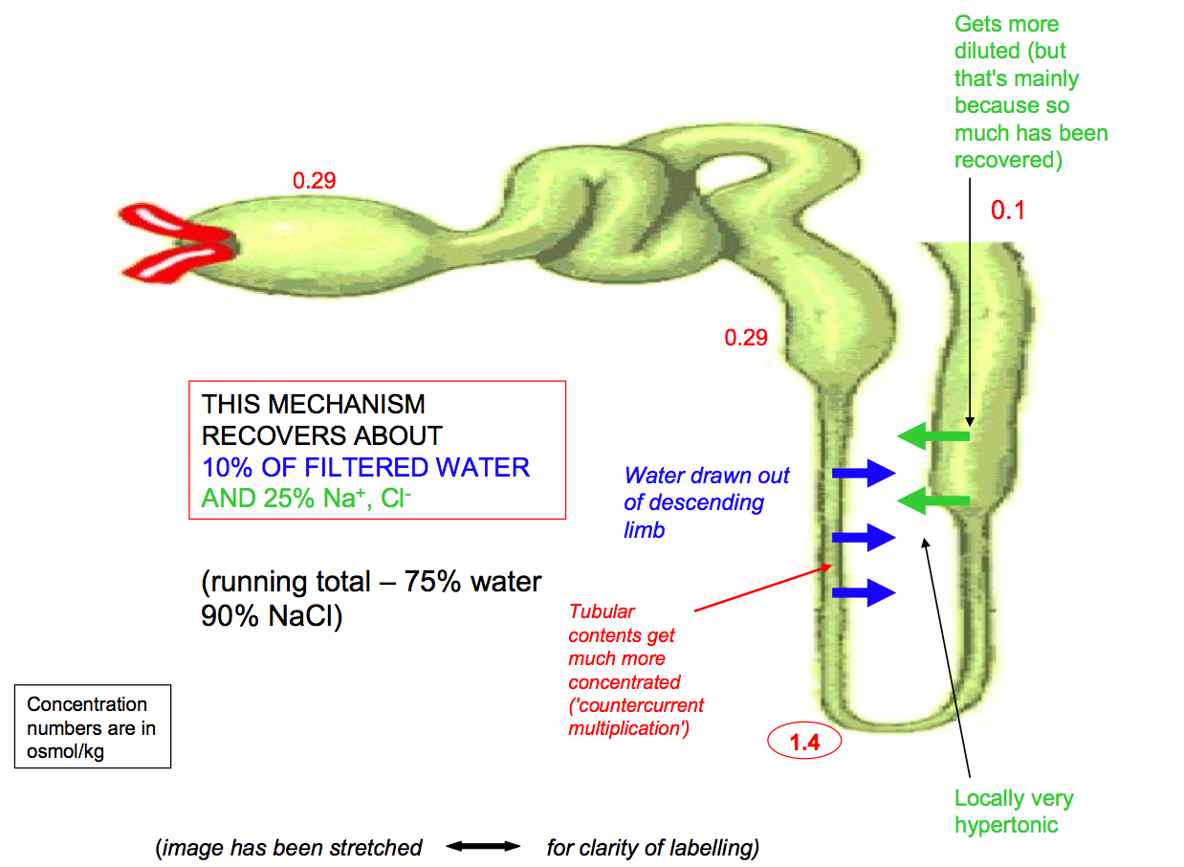

The DCT removes even more salt (c. 5%). When the filtrate leaves the DCT, it loses water to equilibrate with the cortical interstitium, then makes its last journey through the intensely salty medullary interstitium. Here, water is pulled out of it through aquaporins, regulated by AVP (= ADH = vasopressin) and urine can leave at up to 1.4Osmol/kg, a 99% cumulative recovery of water). Also, when passing down the collecting duct, the urine can receive K⁺ and H⁺ (acid/base balance). It also loses some urea, which contributes yet more to the hypertonic zone in the medulla.
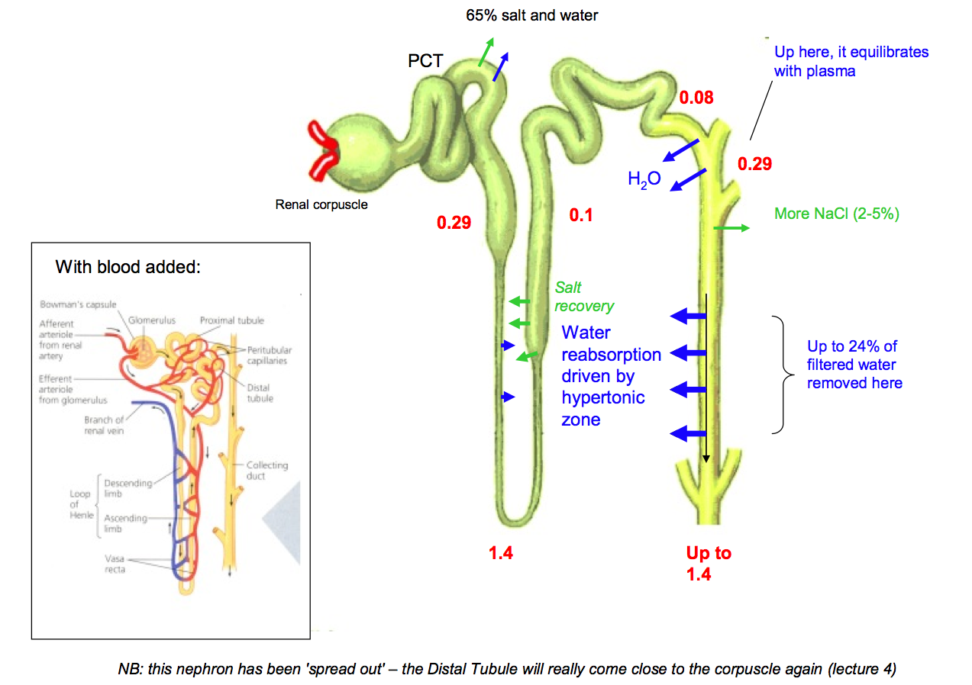

Renal anatomy is vital to the above mechanism for concentrating urine, being arranged so that zones of different osmotic potential are kept separate and flows of filtrate and blood are appropriate. In the ‘middle’ is the pelvis and its calyces, in which urine collects. Surrounding this is the (salty) medulla, through which filtrate makes its last, water-shedding journey in collecting duct. The medulla also contains the LoH, pointing inwards. Outside this is the cortex, where the glomeruli, PCTs and DCT are kept well away from the salty zone. Blood supply to the salty medulla (vasa recta; receives efferent blood from the glomerulus) comes down from and returns up to the cortex; on its way down, the blood gains salt and sheds water and on its way back up the opposite happens, so the gradients are conserved (countercurrent exchange).

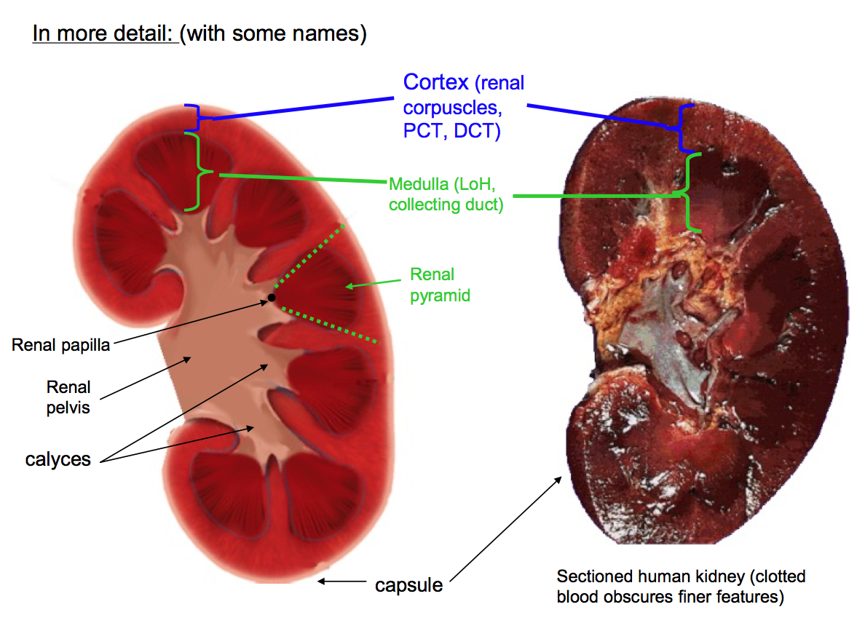

Feedback and regulation
GFR is relatively independent of systemic blood pressure, within limits (c 10.7-24kPa). This is partly a direct myogenic mechanism in the afferent arteriole, ‘holding back’ excess pressure, and partly tubuloglomerular feedback. The DCT makes contact with cells surrounding the afferent and efferent glomerular arterioles as they enter the glomerulus; here the DCT cells become specialized macula densa, and the stromal cells the juxtaglomerular apparatus. Macula densa cells pump NaCl from the filtrate at a rate limited by its concentration in the filtrate. The juxtaglomerular cells respond to high NaCl (=filtrate flowing too fast for proper recovery) by making adenosine, which constricts the afferent arteriole so reduces glomerular blood pressure thence GFR. GFR is therefore controlled according to its own results (‘feedback’).
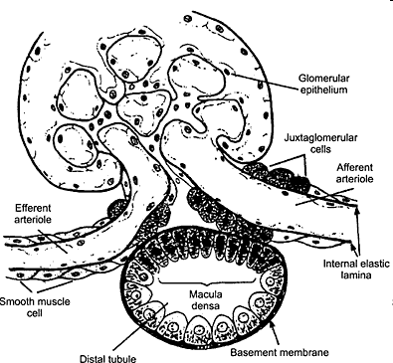

This local feedback could make mistakes, though – if DCT NaCl is high because someone has just eaten a lot of NaCl and it needs to be cleared, reducing GFR would be bad. There are also control loops passing to (renin-angiotensin) and from (eg ANP) the rest of the body.

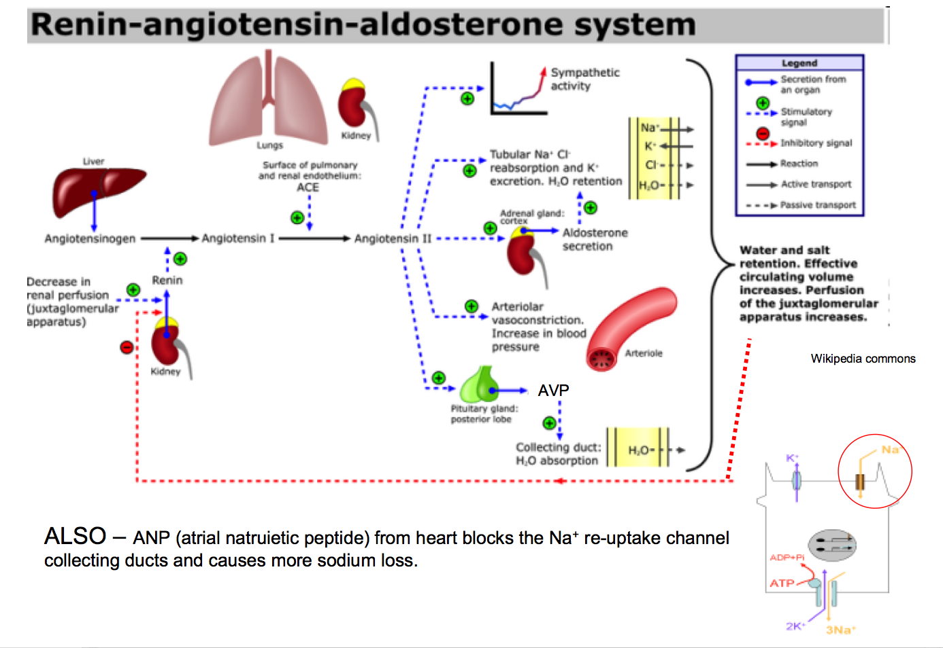

Regulation of K⁺ takes place in the CD (it is recovered constitutively before then, driven by the Na⁺ gradients). Part of this is coupled to H⁺ secretion by intercalated cells; in alkalosis there is less of this (H⁺ precious so not excreted), so there is less re-uptake of K⁺. Acute acidosis has the opposite effect (chronic is compensated by changes in the PCT). CD principal cells secrete K⁺; high tissue levels increase secretion (more available to be pumped in); long-term low K⁺ (eg diet) causes tyrosine phosphorylation of the K⁺ channel and its withdrawal from the membrane, reducing excretion, while high K⁺ has the opposite effect.

Diuretics are drugs intended to interfere directly or indirectly with urine concentrating mechanisms.
- Loop diuretics inhibit SLC12A2 in the TAL, therefore block the pumping of salt into the medullary interstitium, so the urine concentrating mechanism of the LoH/CD does not work properly and dilute urine is passed. Problem: K⁺ recovery in TAL also messed up (and other ions, but K⁺ particularly worrying. High urinary Ca²⁺ can also cause stones).
- Distal tubule diuretics (thiazides) inhibit SLC12A3 (Na,Cl recovery, so tubule contents more salty than normal, so water retained in them for osmotic reasons). K⁺ recovery still messed up in this region,
- Potassium-sparing diuretics: amiloride inhibits ASC in CD cells so Na⁺ uptake impeded, hence water uptake less there. Spironolactone blocks the action of aldosterone on ASC. Carbonic anhydrase inhibitors inhibit bicarb uptake in PCT so keep lumen contents more osmotic so inhibits water uptake later (eg CD).
- Osmotic agents keep the lumen concentrated and water-retaining. The limited capacity for glucose uptake means that diabetes mellitus, with high serum glucose hence high filtrate glucose, has more glucose in filtrate than can be cleared, so water retained in filtrate, so high losses of water (‘diabetes’ = Gk ‘siphon’).

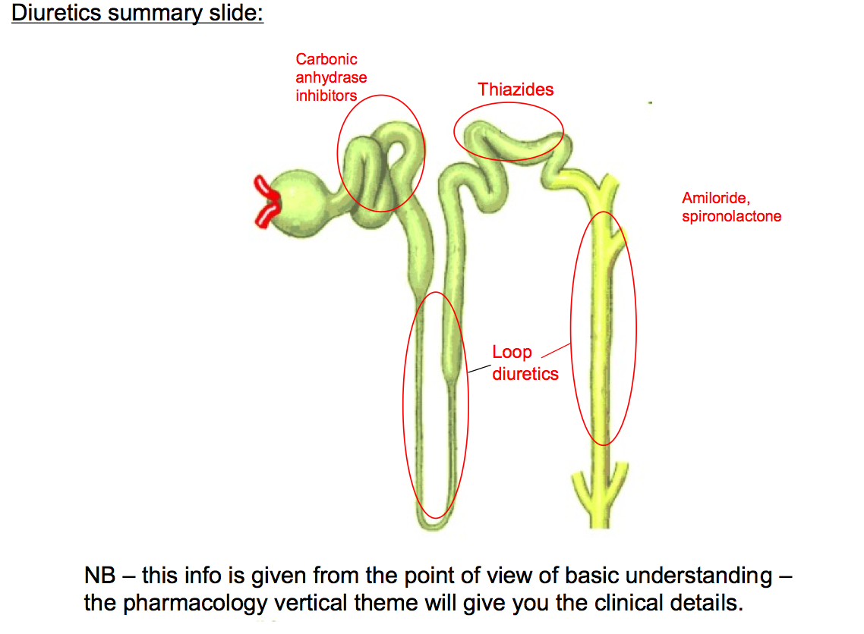

Disorders of transport/ concentrating mechanisms

Syndrome | Molecular defect | Where molecule normally expressed | Clinical effect  (complete this table in lecture 5)
Bartter’s | SLC12A2 | TAL
Giltelman’s | SLC12A3 | DCT
Liddle’s | Hyperactive ASC | CD
Pseudohypoaldosteronism | Inactive ASC | CD
Nephrogenic diabetes insipidus | Aquaporins | CD
Addison’s disease | (destruction of adrenals) | -
Psychogenic polydipsia | - | -

Development of the kidneys
The metanephric kidney used by adult amniotes (reptiles, mammals, birds) is a relatively recent evolutionary innovation and was added to, rather than directly replaced, the less sophisticated mesonephric kidneys of fish and amphibians. Human embryos therefore still make a mesonephros, up in the thoracic region, and its mesonephric (=Wolffian) draining duct that leads away to the cloaca. In females, the mesonephros regresses. In males, the testes develop right next to it, and some mesonephric tubules are ‘hijacked’ by the testis to form its drainage system (rete testis and epididymis), while the mesonephric duct gives rise to most of the ‘male plumbing’ (vas deferens and ejaculatory duct), and accessory glands (seminal vesicles). When the testis descends to the scrotum (pulled by the gubernaculum), these ducts trail behind it, accounting for their path in the adult pelvis.

In both sexes, a side-branch develops from each nephric duct close to where it empties into the cloaca; this is the ureteric bud, which gives rise to the ureters and also, by repeated branching at its end, the collecting duct system of the metanephric kidney. Cells surrounding the branching ureteric bud multiply and groups of them condense, in response to signals from the ureteric bud, to make a nephron (this happens around 100,000-1,000,000 times in a human: protein poor maternal diets mean fewer nephrons, hence higher blood pressure (at least in rodents)– this links nicely with the Barker hypothesis). The nephrons connect with the ureteric bud/ collecting duct branches that induced their formation. Each nephron begins as a curved tube; the middle of the tube extends down into the medulla while the two ends stay close – this is how the distal tubule always comes up to meet the juxtaglomerular apparatus of its own glomerulus. Blood supplies follow, roughly, the branching collecting duct, as do renal nerves (from thoracic and lumbar splanchnic nerves).

From week 10 or so, the kidneys appear to ‘ascend’ in the body from their original position between the hind limbs to the adult location; this ‘ascent’ is really passive - the kidneys remain more or less in place and much of the rest of the body elongates and descends past them.

Development of the lower urinary (/ genital) tract
Bladder: In the early embryo, gut and nephric ducts empty into the cloaca (lat: sewer). This becomes subdivided by the action of 3 folds, a Tourneaux Fold that pushes outwards from inside the embryo, between the urinary and gut systems, and the left and right Rathke folds that push in sideways. These divide the cloaca into the anorectal canal and the urogenital sinus. The upper parts of the urogenital sinus, into which the nephric ducts still run, expand to form the bladder. The lower ends of the nephric ducts ‘melt’ into the bladder wall; once this process has passed beyond the junction between ureter and nephric duct, these two tubes each have their own opening into the bladder. The part of the bladder wall that arises from this, visible as a triangular smooth patch in adults, is called the trigone. Meanwhile, the route to the allantois from the top end of the bladder closes off.

Running (roughly) next to the nephric ducts, which in males make the sperm plumbing (see above) are Müllerian ducts. In males, they regress (testes secrete anti- Müllerian hormone: see year 1). In females, they survive, fuse side-by-side at their lower ends, and contact the urogenital sinus. The unfused parts of the Müllerian ducts become the fallopian tubes, while the fused parts become the uterus and the top of the vagina (lat: sword-sheath): the lower vagina develops from the urogenital sinus itself.

Downstream of the bladder, the urethra of males passes through the prostate (which develops from the urethra in foetal life) and is joined by the ejaculatory ducts - the name given to the old nephric duct downstream of the seminal vesicles. Females are simpler. The exit of urethra from the body is modified by the sex-specific development of the urogenital sinus (from which the urethra develops). In both sexes at a very early stage, the urogenital sinus opens to the body wall ventrally to the anorectal canal, and ventral to this is a mound called the genital tubercle. Again in both sexes, the genital tubercle begins to grow and extend, its tip becoming the glans (lat: acorn) and the sides becoming the shaft of a developing phallus. Tissues at the side of the genital tubercle swell to become the labioscrotal swelling (labium - lat: lip; scrotum - lat: sack).

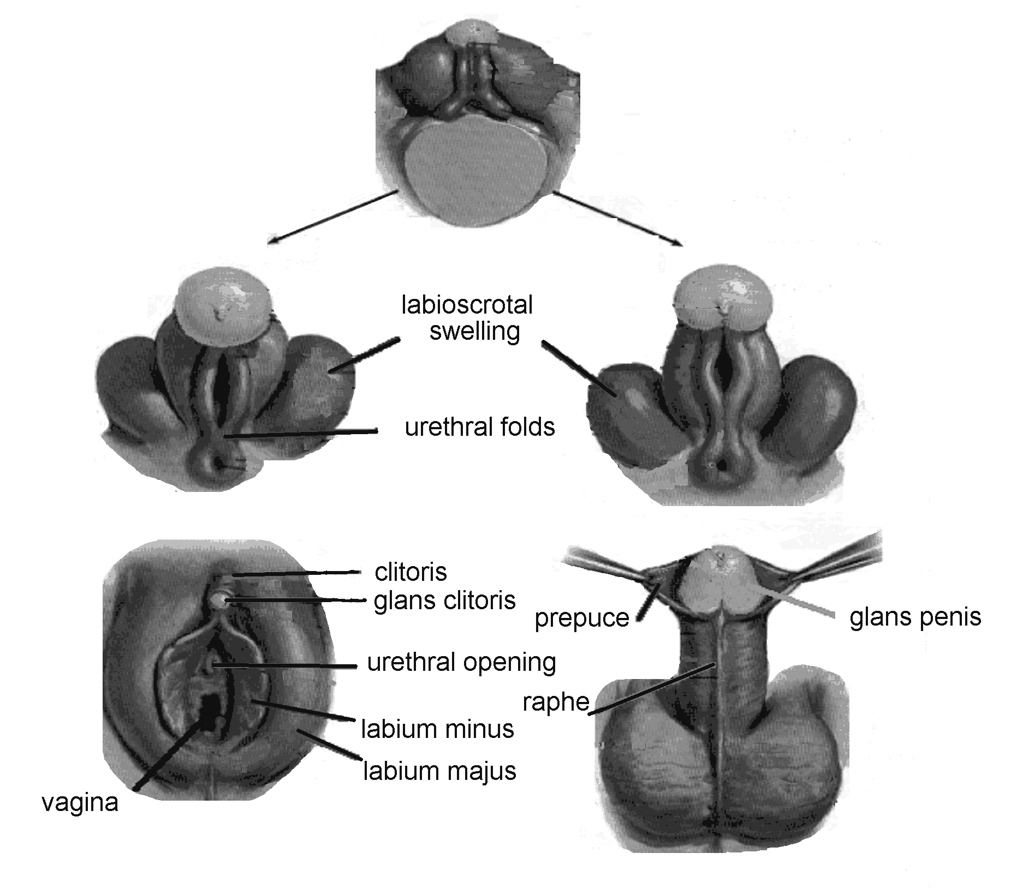

In females, the enlargement of the phallus ceases quite early and the structure becomes the clitoris (gk: cleit=key); the urethral folds are not incorporated into the clitoris but instead form the labia minora which encircle the urogenital sinus, the anterior part of which contains the opening of the urethra and the more posterior part forms the outer portion of the vagina (the inner part of which comes from the Müllerian duct - see above). The labioscrotal folds become the labia majora (which engulf the whole of the vulva area).

In males, the enlargement of the phallus continues and the structure incorporates the urethral fold on its lower surface. The opening of the urethra migrates along this fold towards the tip of the organ, the urethral fold ‘zipping up’ behind it. In this way the opening of the urethra is moved to the tip of the developing penis (lat: tail). The skin of the shaft also grows forward to almost cover the glans area and extend forwards a little to form the prepuce (fore-skin): this is removed in some cultures. The inside of the penis is occupied by corpora spongiosa and cavernosa which, when engorged with blood become hard. Penis growth continues to exceed by far that of the clitoris - by adulthood, mean penis length is 8.4±2.7cm flaccid [16.2±3.2cm erect] compared with just 1.6±0.4cm for the clitoris {deviations from these means have no significant physiological effect in terms of reproduction, but can cause psychological issues you may come across in other courses}.

The difference in male and female development is driven primarily by testosterone, produced in the developing testes (see year 1 semester 1 lectures). Unusual hormone doses can create ‘intersex’ phenotypes.

Congenital Abnormalities of the urinary system

- Bilateral agenesis - no kidneys form. Rare and fatal after birth.
- Unilateral agenesis - quite common (1/500)
- Congential cystic diseases - common - overgrowth of collecting ducts and/or fluid pumps oriented the wrong way round.
- Wilms’ Tumour - ‘islands’ of kidney remain in primitive state and make a tumour very similar to normal developing kidney.
- Supernumerary ureters - while one enters trigone normally, the other often ends up elsewhere on the urogential sinus and therefore empties somewhere silly (vagina, gut etc)
- Pelvic kidney: kidney gets caught in aortic bifurcation and fails to ascend
- Horseshoe kidney - 2 kidneys fuse, often when 2 pelvic kidneys are forced together.
- Urachial Fistula - passage to allantois should have closed but does not.
- Urachial Cyst - while passage to allantois closes at the body wall end, parts remain between there and the bladder.
- Urethral valve - the ureter opens too low so that the prostate balloons under pressure and traps urine, causing more pressure etc.
- Rectovaginal,. Rectoprostatic and rectocloacal canals all result from failure of the folds to separate the cloaca
- Hypospadias – urethral orifice fails to migrate to end of penis.

Supplementary reading list for lower urogenital tract (optional!):

Those of you interested in how we know what we know about the way that male and female genital systems are sculpted ‘from the same clay’ may be interested in a novel based on real anatomical history. It is called “The Anatomist” (Black Swan paperback) and tells the story of the unusual circumstances that led Matteo di Columbo to this discovery. The novel paints a vivid picture of the great days of anatomy, and ends with a post-script that illustrates how ‘pure’ medical knowledge has been misapplied to mutilate and to oppress in the name of religion. Please note, though, that the novel is sexually explicit (the story could not be told any other way).

Anyone interested in the psychosocial aspects of this general area of the body may also want to catch The Vagina Monologues (usually performed in the Edinburgh Festival).

